|  |  |  |  |  |  |  |  |  |  |  |  |  |  |  |  |  |  |  |  |  |  |  |  |
| --- | --- | --- | --- | --- | --- | --- | --- | --- | --- | --- | --- | --- | --- | --- | --- | --- | --- | --- | --- | --- | --- | --- | --- |
| Name | : |  |  |  |  |  |  |  |  |  |  |  |  |  |  |  |  |  |  |  |  |  |  |
|  | | | | | | | | | | | | | | | | | | | | | | | |

Java 1 Test Paper

**Duration : 50 Mins.**

#### For Office Use Only

|  |  |  |
| --- | --- | --- |
| Checked by | …………………………………… | |
| Date | …………………………………… | |
| Marks Obtained |  |  |

**Total Marks : 50 Marks**

**General Instructions :**

* **All questions are compulsory**
* **No negative marking system**

1) Which collection class allows you to grow or shrink its size and provides indexed access to its elements, but whose methods are not synchronized?

A. java.util.HashSet

B. java.util.LinkedHashSet

C. java.util.List

D. java.util.ArrayList

2) You need to store elements in a collection that guarantees that no duplicates are stored and all elements can be accessed in natural order. Which interface provides that capability?

A. java.util.Map

B. java.util.Set

C. java.util.List

D. java.util.Collection

|  |
| --- |
| 3)public class While  {  public void loop()  {  int x= 0;  while ( 1 ) /* Line 6 */  {  System.out.print("x plus one is " + (x + 1)); /* Line 8 */  }  }  }  Which statement is true? |
| |  |  | | --- | --- | | [A.](javascript:%20void%200;) | There is a syntax error on line 1. | | [B.](javascript:%20void%200;) | There are syntax errors on lines 1 and 6. | | [C.](javascript:%20void%200;) | There are syntax errors on lines 1, 6, and 8. | | [D.](javascript:%20void%200;) | There is a syntax error on line 6. | | 4). | What will be the output of the program?  public class Foo  {  public static void main(String[] args)  {  try  {  return;  }  finally  {  System.out.println( "Finally" );  }  }  } | | |  |  | | --- | --- | | [A.](javascript:%20void%200;) | Finally | | [B.](javascript:%20void%200;) | Compilation fails. | | [C.](javascript:%20void%200;) | The code runs with no output. | | [D.](javascript:%20void%200;) | An exception is thrown at runtime. | | |

5) - What is the size of int variable?

A - 8 bit

B - 16 bit

C - 32 bit

D - 64 bit

**6) True or False (Marks : 6)**

1. Array is a static data structure true
2. Every class in Java is an Object true
3. In case of method overriding return type never plays any role false
4. Generics provide compile time type safety true
5. Interface can not be instantiated true
6. String is immutable. true

**7) Select Correct Option.**

To run a java application we need?

1. JRE
2. JDK
3. IDE
4. None of the above

8) If a method used in a super class is critical and you have been asked to implement a

method in such a way that only subclasses are allowed to use the method, then

which type of access specifier you will prefer?

a) public

b) private

c) package

d) protected

9) In Java constructor chaining always start from Object class

a) True

b) False

10) If you want to call a stored procedure or function from java code which of the following API is

suitable

a) Statement

b) CallableStatement

c) PreparedStatement

11) Which of the following statements are true?

1) **Constructors cannot have a visibility modifier  
2) Constructors can be marked public and protected, but not private  
3) Constructors can only have a primitive return type  
4) Constructors are not inherited**

12) Which of the following methods are members of the ArrayList class and allow you to input a new element

1) add  
2) insert  
3) append  
4) addItem

13) what is return by executable query?

a>integer

b>string

c>boolean

d>resultSet

14) Which one is the best java driver for database middlewire:

a>Type1

b>Type2

c>Type3

d>Type4

15. Which of these method of class String is used to compare two String objects for their equality?  
a) equals()  
b) Equals()  
c) isequal()  
d) Isequal()

16. What is the output of this program?

1. **class** output {
2. **public** **static** **void** main(String args[])
3. {
4. String s1 = "Hello i love java";
5. String s2 = **new** String(s1);
6. System.out.println((s1 == s2) + " " + s1.equals(s2));
7. }
8. }

a) true true  
b) false false  
c) true false  
d) false true

17. Which of these keyword must be used to inherit a class?  
a) super  
b) this  
c) extent  
d) extends

18. What is the output of this program?

1. **class** A {
2. **int** i;
3. **void** display() {
4. System.out.println(i);
5. }
6. }
7. **class** B **extends** A {
8. **int** j;
9. **void** display() {
10. System.out.println(j);
11. }
12. }
13. **class** inheritance_demo {
14. **public** **static** **void** main(String args[])
15. {
16. B obj = **new** B();
17. obj.i=1;
18. obj.j=2;
19. obj.display();
20. }
21. }
22. 0  
    b) 1  
    c) 2  
    d) Compilation Error

19) Problem Statement (Marks-5)

* An organization is interested in automating the process of newly joined employee in such a way that an HR department’s **Employee creation system** should be in a position to create a new Employee with automatically generated sequential employee id. The system should be in a position to accept only First name, Last name, salary, grade and Joining month in “mmm:yyyy” format. The system should be able to track at any time how many employees they have been created.
* Model a software system for above problem domain with proper UML notations.
* Write a test class for testing the system

**20)**

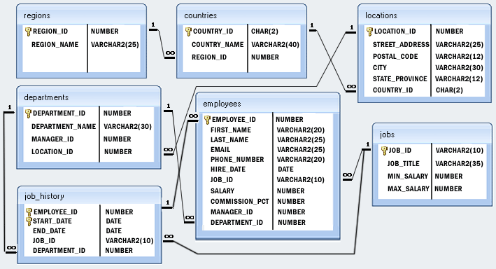

Write a query to get the department ID and the total salary payable in each department.(Marks 5)

SELECT department_id, SUM(salary) FROM employees GROUP BY department_id;